CODE:

CREATE TABLE STUDENT10 (

USN VARCHAR (10) PRIMARY KEY,

SNAME VARCHAR (25),

ADDRESS VARCHAR (25),

PHONE NUMBER (10),

GENDER CHAR (1));

CREATE TABLE SEMSEC (

SSID VARCHAR (5) PRIMARY KEY,

SEM NUMBER (2),

SEC CHAR (1));

CREATE TABLE CLASS10 (

USN VARCHAR (10),

SSID VARCHAR (5),

PRIMARY KEY (USN, SSID),

FOREIGN KEY (USN) REFERENCES STUDENT10 (USN),

FOREIGN KEY (SSID) REFERENCES SEMSEC (SSID));

CREATE TABLE SUBJECT (

SUBCODE VARCHAR (8),

TITLE VARCHAR (20),

SEM NUMBER (2),

CREDITS NUMBER (2),

PRIMARY KEY (SUBCODE));

CREATE TABLE IAMARKS (

USN VARCHAR (10),

SUBCODE VARCHAR (8),

SSID VARCHAR (5),

TEST1 NUMBER (2),

TEST2 NUMBER (2),

TEST3 NUMBER (2),

FINALIA NUMBER (2),

PRIMARY KEY (USN, SUBCODE, SSID),

FOREIGN KEY (USN) REFERENCES STUDENT10 (USN),

FOREIGN KEY (SUBCODE) REFERENCES SUBJECT (SUBCODE),

FOREIGN KEY (SSID) REFERENCES SEMSEC (SSID));

INSERT INTO STUDENT10 VALUES ('1RN13CS020','AKSHAY','BELAGAVI', 8877881122,'M');

INSERT INTO STUDENT10 VALUES ('1RN13CS062','SANDHYA','BENGALURU', 7722829912,'F');

INSERT INTO STUDENT10 VALUES ('1RN13CS091','TEESHA','BENGALURU', 7712312312,'F');

INSERT INTO STUDENT10 VALUES ('1RN13CS066','SUPRIYA','MANGALURU', 8877881122,'F');

INSERT INTO STUDENT10 VALUES ('1RN14CS010','ABHAY','BENGALURU', 9900211201,'M');

INSERT INTO STUDENT10 VALUES ('1RN14CS032','BHASKAR','BENGALURU', 9923211099,'M');

INSERT INTO STUDENT10 VALUES ('1RN14CS025','ASMI','BENGALURU', 7894737377,'F');

INSERT INTO STUDENT10 VALUES ('1RN15CS011','AJAY','TUMKUR', 9845091341,'M');

INSERT INTO STUDENT10 VALUES ('1RN15CS029','CHITRA','DAVANGERE', 7696772121,'F');

INSERT INTO STUDENT10 VALUES ('1RN15CS045','JEEVA','BELLARY', 9944850121,'M');

INSERT INTO STUDENT10 VALUES ('1RN15CS091','SANTOSH','MANGALURU', 8812332201,'M');

INSERT INTO STUDENT10 VALUES ('1RN16CS045','ISMAIL','KALBURGI', 9900232201,'M');

INSERT INTO STUDENT10 VALUES ('1RN16CS088','SAMEERA','SHIMOGA', 9905542212,'F');

INSERT INTO STUDENT10 VALUES ('1RN16CS122','VINAYAKA','CHIKAMAGALUR', 8800880011,'M');

INSERT INTO SEMSEC VALUES ('CSE8A', 8,'A');

INSERT INTO SEMSEC VALUES ('CSE8B', 8,'B');

INSERT INTO SEMSEC VALUES ('CSE8C', 8,'C');

INSERT INTO SEMSEC VALUES ('CSE7A', 7,'A');

INSERT INTO SEMSEC VALUES ('CSE7B', 7,'B');

INSERT INTO SEMSEC VALUES ('CSE7C', 7,'C');

INSERT INTO SEMSEC VALUES ('CSE6A', 6,'A');

INSERT INTO SEMSEC VALUES ('CSE6B', 6,'B');

INSERT INTO SEMSEC VALUES ('CSE6C', 6,'C');

INSERT INTO SEMSEC VALUES ('CSE5A', 5,'A');

INSERT INTO SEMSEC VALUES ('CSE5B', 5,'B');

INSERT INTO SEMSEC VALUES ('CSE5C', 5,'C');

INSERT INTO SEMSEC VALUES ('CSE4A', 4,'A');

INSERT INTO SEMSEC VALUES ('CSE4B', 4,'B');

INSERT INTO SEMSEC VALUES ('CSE4C', 4,'C');

INSERT INTO SEMSEC VALUES ('CSE3A', 3,'A');

INSERT INTO SEMSEC VALUES ('CSE3B', 3,'B');

INSERT INTO SEMSEC VALUES ('CSE3C', 3,'C');

INSERT INTO SEMSEC VALUES ('CSE2A', 2,'A');

INSERT INTO SEMSEC VALUES ('CSE2B', 2,'B');

INSERT INTO SEMSEC VALUES ('CSE2C', 2,'C');

INSERT INTO SEMSEC VALUES ('CSE1A', 1,'A');

INSERT INTO SEMSEC VALUES ('CSE1B', 1,'B');

INSERT INTO SEMSEC VALUES ('CSE1C', 1,'C');

INSERT INTO CLASS10 VALUES ('1RN13CS020','CSE8A');

INSERT INTO CLASS10 VALUES ('1RN13CS062','CSE8A');

INSERT INTO CLASS10 VALUES ('1RN13CS066','CSE8B');

INSERT INTO CLASS10 VALUES ('1RN13CS091','CSE8C');

INSERT INTO CLASS10 VALUES ('1RN14CS010','CSE7A');

INSERT INTO CLASS10 VALUES ('1RN14CS025','CSE7A');

INSERT INTO CLASS10 VALUES ('1RN14CS032','CSE7A');

INSERT INTO CLASS10 VALUES ('1RN15CS011','CSE4A');

INSERT INTO CLASS10 VALUES ('1RN15CS029','CSE4A');

INSERT INTO CLASS10 VALUES ('1RN15CS045','CSE4B');

INSERT INTO CLASS10 VALUES ('1RN15CS091','CSE4C');

INSERT INTO CLASS10 VALUES ('1RN16CS045','CSE3A');

INSERT INTO CLASS10 VALUES ('1RN16CS088','CSE3B');

INSERT INTO CLASS10 VALUES ('1RN16CS122','CSE3C');

INSERT INTO SUBJECT VALUES ('10CS81','ACA', 8, 4);

INSERT INTO SUBJECT VALUES ('10CS82','SSM', 8, 4);

INSERT INTO SUBJECT VALUES ('10CS83','NM', 8, 4);

INSERT INTO SUBJECT VALUES ('10CS84','CC', 8, 4);

INSERT INTO SUBJECT VALUES ('10CS85','PW', 8, 4);

INSERT INTO SUBJECT VALUES ('10CS71','OOAD', 7, 4);

INSERT INTO SUBJECT VALUES ('10CS72','ECS', 7, 4);

INSERT INTO SUBJECT VALUES ('10CS73','PTW', 7, 4);

INSERT INTO SUBJECT VALUES ('10CS74','DWDM', 7, 4);

INSERT INTO SUBJECT VALUES ('10CS75','JAVA', 7, 4);

INSERT INTO SUBJECT VALUES ('10CS76','SAN', 7, 4);

INSERT INTO SUBJECT VALUES ('15CS51', 'ME', 5, 4);

INSERT INTO SUBJECT VALUES ('15CS52','CN', 5, 4);

INSERT INTO SUBJECT VALUES ('15CS53','DBMS', 5, 4);

INSERT INTO SUBJECT VALUES ('15CS54','ATC', 5, 4);

INSERT INTO SUBJECT VALUES ('15CS55','JAVA', 5, 3);

INSERT INTO SUBJECT VALUES ('15CS56','AI', 5, 3);

INSERT INTO SUBJECT VALUES ('15CS41','M4', 4, 4);

INSERT INTO SUBJECT VALUES ('15CS42','SE', 4, 4);

INSERT INTO SUBJECT VALUES ('15CS43','DAA', 4, 4);

INSERT INTO SUBJECT VALUES ('15CS44','MPMC', 4, 4);

INSERT INTO SUBJECT VALUES ('15CS45','OOC', 4, 3);

INSERT INTO SUBJECT VALUES ('15CS46','DC', 4, 3);

INSERT INTO SUBJECT VALUES ('15CS31','M3', 3, 4);

INSERT INTO SUBJECT VALUES ('15CS32','ADE', 3, 4);

INSERT INTO SUBJECT VALUES ('15CS33','DSA', 3, 4);

INSERT INTO SUBJECT VALUES ('15CS34','CO', 3, 4);

INSERT INTO SUBJECT VALUES ('15CS35','USP', 3, 3);

INSERT INTO SUBJECT VALUES ('15CS36','DMS', 3, 3);

INSERT INTO IAMARKS VALUES ('1RN13CS091','10CS81','CSE8C', 15, 16, 18,16);

INSERT INTO IAMARKS VALUES ('1RN13CS091','10CS82','CSE8C', 12, 19, 14,18);

INSERT INTO IAMARKS VALUES ('1RN13CS091','10CS83','CSE8C', 19, 15, 20,18);

INSERT INTO IAMARKS VALUES ('1RN13CS091','10CS84','CSE8C', 20, 16, 19,19);

INSERT INTO IAMARKS VALUES ('1RN13CS091','10CS85','CSE8C', 15, 15, 12,13);

select * from student10;

select * from semsec;

select * from class10;

select * from subject;

select * from iamarks;

SELECT S.*, SS.SEM, SS.SEC

FROM STUDENT10 S, SEMSEC SS, CLASS10 C

WHERE S.USN = C.USN AND

SS.SSID = C.SSID AND

SS.SEM = 4 AND SS.SEc='C';

SELECT SS.SEM, SS.SEC, S.GENDER, COUNT (S.GENDER) AS COUNT

FROM STUDENT10 S, SEMSEC SS, CLASS10 C

WHERE S.USN = C.USN AND

SS.SSID = C.SSID

GROUP BY SS.SEM, SS.SEC, S.GENDER

ORDER BY SEM;

CREATE VIEW STU_TEST1_MARKS_VIEW

AS

SELECT TEST1, SUBCODE

FROM IAMARKS

WHERE USN = '1RN13CS091';

select * from STU_TEST1_MARKS_VIEW ;

SELECT S.USN,S.SNAME,S.ADDRESS,S.PHONE,S.GENDER,

(CASE

WHEN IA.FINALIA BETWEEN 17 AND 20 THEN 'OUTSTANDING'

WHEN IA.FINALIA BETWEEN 12 AND 16 THEN 'AVERAGE'

ELSE 'WEAK'

END) AS CAT

FROM STUDENT10 S, SEMSEC SS, IAMARKS IA, SUBJECT SUB

WHERE S.USN = IA.USN AND

SS.SSID = IA.SSID AND

SUB.SUBCODE = IA.SUBCODE AND

SUB.SEM = 8;

TABLES:

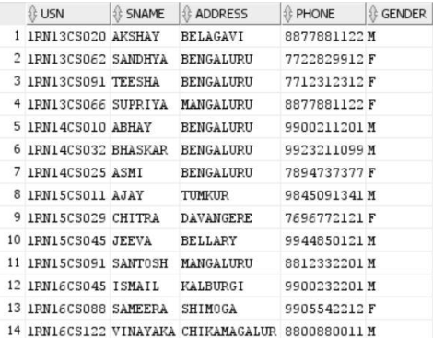

Student:

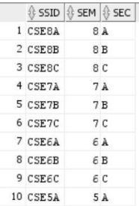

Semsec:

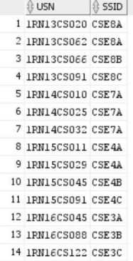Class:

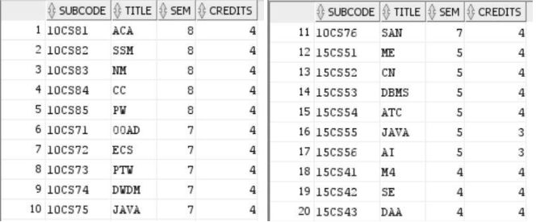Subject:

Marks:

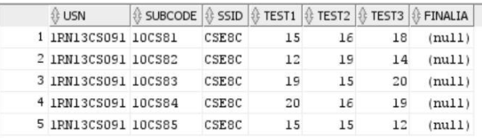

QUERY 1



QUERY 2

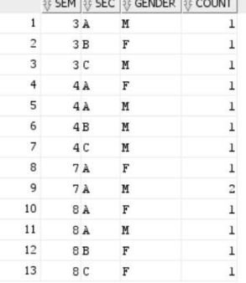

QUERY 3 QUERY 4

